Kangaroo Legs Spec Sheet 10/19/13

**Purpose:** To outline the actions associated with CCC Kangaroo Legs (KL). These specifications will be called if the user taps the “Kangaroo Leg” icon in the “Superpower Drawer”.

**Graphics Definitions:** This section will define general terms for graphics and UI. These terms will be used in tables containing specs for individual graphics.

**Stop/Wait Graphics (SWG):** These graphics will be used when waiting for the user to interact with the game or in specific cases (wait for instructions, fell down, etc).

**Action Graphics (AG):** These graphics will be objects that have a short, looping animation associated with them (running, jumping) that are called with a specific UI gesture.

**Transition Animations (TA):** If a transition animation is called (between superpowers, stand to crawl, etc), the right hand regions should stop listening for finger contact until the end of the transition animation. If at the end of the animation there is no finger, the “stop” or “waiting” graphic will be called.

**User Interface**: The screen will be split into regions 1-4, see Figure 1:

**Region 1 (left hand region)**- To be controlled with the left thumb or finger. The region will listen for taps or swipes that will control specific actions and or call specific animations (jumping). The specific call action associated with each graphic can be found in Table 1.

**Region 3 and 4 (right hand regions):** These regions will be used to control the direction of CCC-KL by the right thumb or finger. There is only one speed associated with this superpower. If the user’s thumb is in region 3, CCC will move left. If their thumb is in region 4, CCC will move right. If they REMOVE their thumb, CCC will stop.

**Region 2:** This region is meant to provide a buffer between the left side and the right side of the screen. If their right finger crosses the line between 2 and 3 CCC will continue running left. In the event their right thumb crosses into region 1, ideally, the “stop” animation will be called. I’m not really sure the best way to use region 2 to prevent confusing right hand and left hand actions.

**Buttons:** The actions associated with the red “Main Menu” button in the bottom left corner and the purple and gray “Superpower Drawer” button in the top right should only be called when tapped. There may need to be boundaries around these buttons to separate the region they occupy from action regions 1-4.

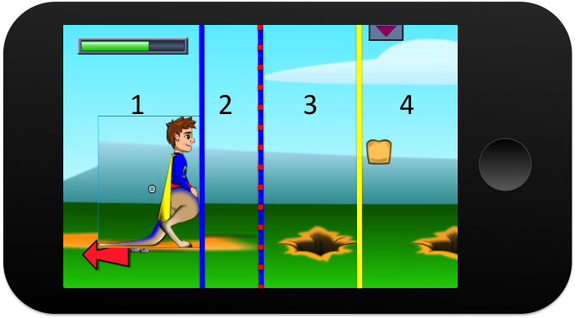

Figure1. The different UI for KL regions. Region 1-action region, region 2-buffer, region 3-left, region 4-right.

**The following actions are the only ones associated with Kangaroo legs.**

|  |  |  |  |  |  |
| --- | --- | --- | --- | --- | --- |
| **Action**  (Width x Height in pixels) | **Purpose** | **Boundary/Obstacle Interactions** | **Figure Kinetics** | **User Interface** | Energy |
| KL-Standing (252.4 x 279) | SWG-Wait action for KL. | Gravity pulling CCC down to boundary line. | No movement, x or y. | The user is not interacting with the right-handed region. Also called if the character falls more than 800 px. | 0 |
| KL-Running  Height (274.35 x 255) | AG-Move CCC-KL laterally. | Gravity pulling down to boundary line. Stop when hit a boundary line taller than **81 px** in the positive y-direction (eg a wall). Continue moving if encounter a boundary line shorter than **80px** (eg a high step). | Rate: **459 px/s**  Only control movement along x-axis, movement along y-axis dictated by boundary line. | Finger in region 3-left. Finger in region 4-right | 0 |
| KL-Jumping  (292.9 x 230) | AG-Jump over larger distances/bigger obstacles than CCC-Human. | Gravity pulling down to boundary line. | Max Jumping height: **225 px**  Lateral rate match rate determined by interaction with right hand region. | Tap to jump in region 1. Finger in region 3 or 4 determine direction and speed of jump. No finger, jump straight up. | -1 |